Bus Simulation Report

By Nakul Suresh and Hunter Warner

In our simulation, we varied the amounts of buses tested: 14, 12 and 10. We wanted to use enough buses to accommodate the riders; our rationale was that too few buses would cause long wait times. Each of these amounts of buses were also tested using three different loads to simulate rush hour, average turn out, and off-peak. In addition, we varied the amount of normal buses and express buses. In terms of riders, we kept track of average crowd sizes for both normal and express buses, average queue lengths of normal and popular stops and finally the maximum queue length. On the other hand, we also noted the average wait time of a rider before boarding the bus, his or her maximum wait time before boarding the bus and the average travel time which includes wait time and time on the bus.

This simulation does not account for clumping which results in skewed data. First, we had to evenly spread the buses amongst the 30 bus stops. For the amounts of buses that were not divisible by 30, the spread was not entirely even. This is one possible source of buses clumping together. Another possible source is the randomness factor in the creation of simulated riders. In one extreme, one bus stop can perpetually create 75% more riders than average, while another bus stop creates 75% less riders than the average. As a result, the buses will have varying amounts of riders. The buses with more riders will travel slower through the route than the buses with lesser riders, giving the opportunity for the lesser populated buses to catch up.

Moreover, the data presented below are rounded to the nearest whole number because the decimal amount is negligible. Furthermore, we standardized using 4 hours for our simulation in order to make our data comparable. This is also a realistic duration for peak hour. Lastly, data for crowd size was separated by whether the crowd was in an express bus or normal bus; data for average queue lengths was separated by whether the queue was at a popular stop or a normal stop. Overall averages would not distinguish the data for express buses or popular stops.

14 Buses Run:

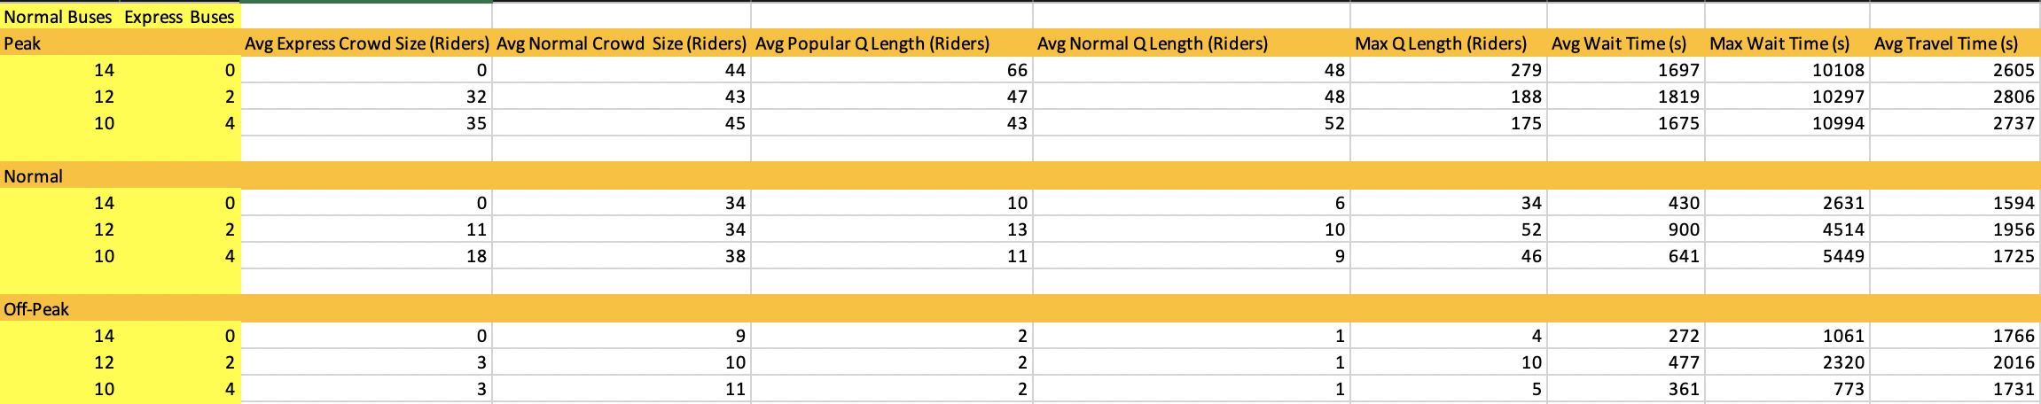The average queue lengths remain similar in all three load scenarios. Regarding maximum queue length, our data hovered around the same range regardless of the amount of normal and express buses. It is a good indicator of anomalies shown in the simulation. Similarly, the average crowd sizes for both express and normal buses stayed in the same range. In terms of average and maximum wait time, there was no distinct pattern. Additionally, the average travel time is the slowest when two express buses are introduced. Regardless of load, the average travel time was comparably lower without express buses than the combinations with express buses.

12 Buses Run: 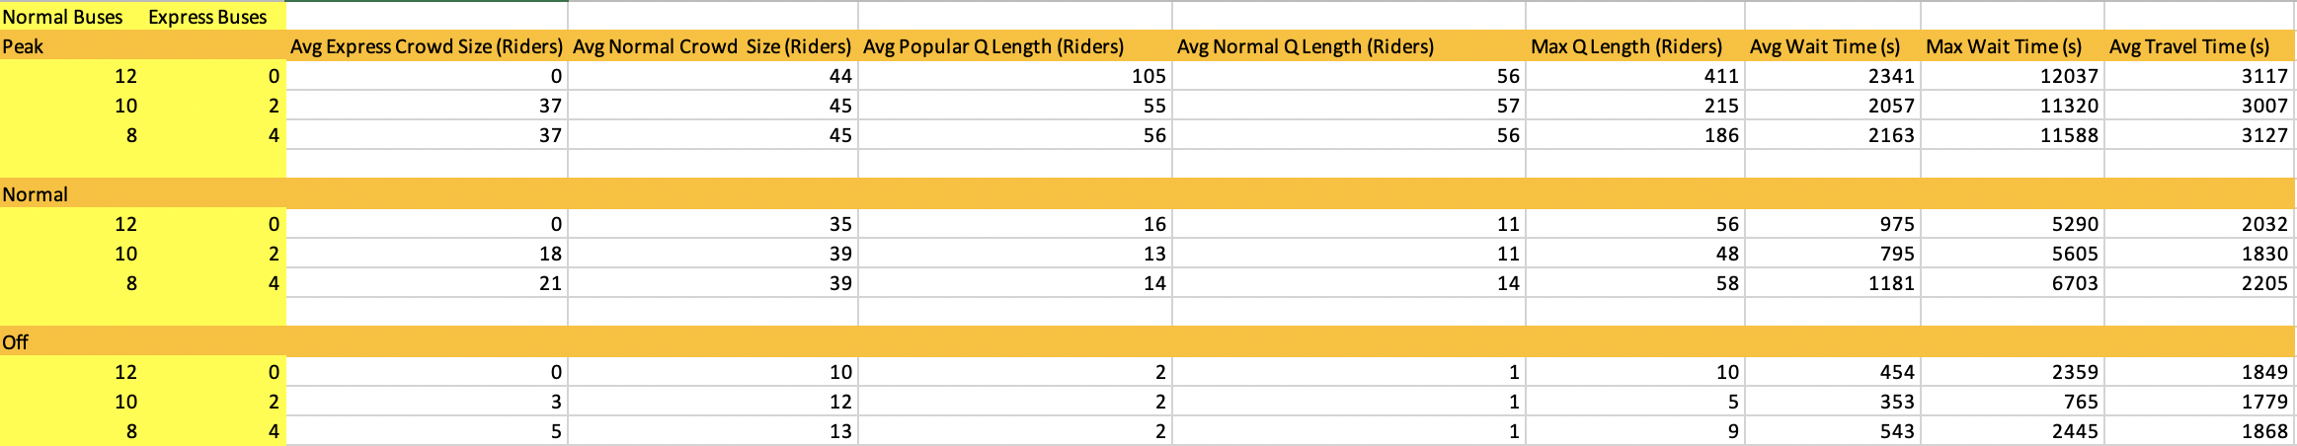

The average crowd size for both express and normal buses is independent of the amount of express buses and normal buses. The average queue length for popular stops along with max queue length is decreased once two express buses are introduced; however, further increasing the amount of express buses had either no effect or slightly increased the popular stops’ average queue length. In addition, the normal stops’ queue was unchanged as more express buses were added to the simulation. Lastly, the average travel time was smallest for the 10 normal buses and 2 express buses combination.

10 Buses Run:

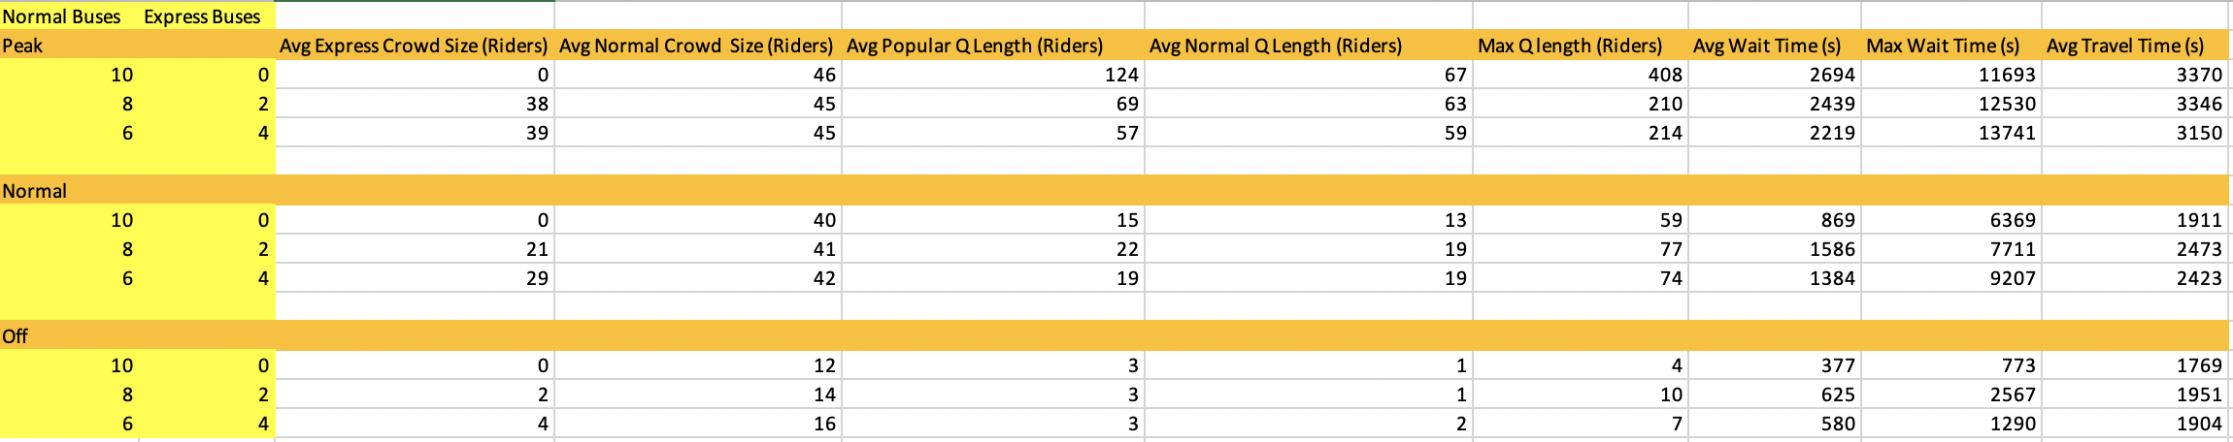

The average crowd size for both express and normal buses is independent of the combination of express buses and normal buses. During peak time, the max queue length was smallest when there were either two express and eight normal buses or four express and six normal buses. For normal and off-peak hours, having ten normal buses resulted in the smallest max queue. Moreover, the average travel time for peak time was smallest for the six normal bus and 4 express bus combination, while for normal and off-peak time, the average travel time was smallest when there were ten normal buses.

While testing to see if our data was in equilibrium, we compared the exact same parameters using 100,000 seconds instead. Our time data tended to increase indicating that the simulation was not at equilibrium. This is because even 14 buses are likely not enough to be able to keep up with the demand of riders created. However, our data approached equilibrium while testing the off-peak scenario because the riders were created at a much slower rate. In conclusion, the bus company should consider using more than 14 buses to run on a daily basis.